WAH for Hospitals (WAH4H)

Project Documentation Submitted to the Faculty of the
School of Computing and Information Technologies

Asia Pacific College

In Partial Fulfillment of the Requirements for
Introduction to Systems and Design for IT
SNTSDEV

By
Mariyah Vanna Monique C. Chavez | John Kenneth L. Jajurie
Jhon Lloyd R. Nicolas | Elijah Josh R. Quibin

Table of Contents
List of Figures iv
List of Tables v
Introduction 6
Project Context 7
Statement of the Problem 8
Research Questions 8
Objectives 9
Main Objective 9
Significance of the Project 10
Scope and Limitations 12
Review of Related Literature / Systems 13
Current System 17
SWOT Analysis 21
Proposed Solution 23
Technical Background 24
Feasibility 25
Operational Feasibility 25
Economic Feasibility 26
Technical Feasibility 27
Schedule Feasibility 28
Requirements Analysis 29
Project Vision 29
Prototype (Mock Flow / Wireframe) 29
Project Lean Canvas 38
User Classes and Characteristics 38
Product Backlog 39
Product Roadmap 40
Release Plan 41
Use Case Diagram 41
Use Case Full Description 42
Conclusion 42
References 44
Appendices 45
Appendix A: Roles and Responsibilities 45
Appendix B: Minutes of the Meetings 46
Appendix C: Methodology 54
Appendix D: Project Sharepoint Link 55
Appendix E: Requirements Traceability Matrix 55
Appendix F: RACI Matrix 55

List of Figures

Figure 1. Login Page 29
Figure 2. Sign Up Page 30
Figure 3. System Dashboard Tab 30
Figure 4. Modules Selection Tab 31
Figure 5. Patients Management Tab 31
Figure 6. Philhealth E-Claims Tab 32
Figure 7. Patient Discharge Tab 32
Figure 8. Inventory Management Tab 33
Figure 9. Lab Technician Tab 33
Figure 10. Control Panel Tab 34
Figure 11. Compliance Management 34
Figure 12. Billing Tab 35
Figure 13. Enterprise Resources Planning Tab 35
Figure 14. Statistics & Analytics Tab 36
Figure 15. A.I. Chat Bot 37
Figure 16. Lean Canvas 38
Figure 17. Project Roadmap for WAH4H 40
Figure 18. Use Case Diagram 41

List of Tables
Table 1. Core hospital processes executed using entirely manual methods 18
Table 2. Semi-digital workflows in hospitals using low-satisfaction HIMS. 20
Table 3. SWOT Analysis for WAH's Business Process 22
Table 4. User Roles and Description 39
Table 5. Product Backlog 40
Table 6. Pseudoers Assignment of Tasks per Week 46

Introduction
The evolving landscape of healthcare in the Philippines underscores the growing necessity for digital transformation, particularly in community hospitals that continue to rely on manual systems for patient records, billing, and government reporting. As highlighted in recent analyses of healthcare IT, the most challenging step is often the very first: transitioning from paper-based processes to functional digital systems [1]. This “first mile” is critical, as reliance on manual workflows leads to fragmented information, delays in access, transcription errors, and inefficiencies in administrative and reporting tasks [2].
Despite national efforts to modernize healthcare, many small to mid-sized hospitals—especially those managed by Local Government Units (LGUs)—struggle to adopt existing hospital information systems (HIS). Common barriers include high system complexity, lack of local customization, and insufficient digital literacy among staff. These challenges not only affect daily operations but also hinder compliance with government requirements, such as PhilHealth e-claims and Department of Health (DOH) reporting standards [3].
To help address these issues, Wireless Access for Health (WAH) serves as a foundational partner in supporting the digital transformation of healthcare facilities. WAH’s mission is to provide cost-effective, standards-based digital solutions that align with the workflows of LGU-managed hospitals and clinics. The organization has successfully enabled rural health units to improve data accuracy, increase operational efficiency, and streamline government-mandated reporting through earlier EMR deployments [4], [5].
Building on this experience, the proposed WAH4Hospital system is currently being conceptualized to serve as a hospital information system tailored for small to mid-sized Philippine hospitals. Although still in the planning and design phase, WAH4Hospital will be developed to digitize critical workflows such as patient registration, billing, PhilHealth claims processing, and DOH-compliant reporting. Its modular design and role-based access will ensure that the system remains both scalable and usable for a wide range of hospital personnel.
This initiative directly supports the implementation of the Universal Health Care (UHC) Law, officially known as Republic Act No. 11223 [6], which mandates equitable access to quality healthcare and emphasizes the need for integrated health information systems across all levels of care. By adopting a user-centered and practical design approach, WAH4Hospital contributes to the modernization of community health facilities in alignment with global development targets, particularly Sustainable Development Goal (SDG) 3: Good Health and Well-being and SDG 9: Industry, Innovation, and Infrastructure.
The system aims to enhance operational efficiency and regulatory compliance in small to mid-sized hospitals, thereby supporting both national goals for digital health transformation and broader efforts to achieve universal healthcare coverage.

Project Context
Philippine community hospitals, especially those managed by Local Government Units (LGUs), often face challenges in managing daily operations due to limited access to digital systems. At Cuyapo Infirmary, the current workflow involves manually handling patient records, billing, and PhilHealth claims. This results in delays, errors in documentation, and difficulty tracking patient history or service statistics, all of which affect service delivery and compliance with regulatory standards.
‎The Information Systems gap also creates a burden on hospital staff, many of whom are not formally trained in digital tools, making any potential software difficult to adopt unless carefully tailored to their workflow and skill level. Additionally, generating DOH and FHSIS-compliant reports is time-consuming and error-prone, which poses risks to the hospital’s eligibility for reimbursements and program participation.
Given these circumstances, Wireless Access for Health (WAH), in collaboration with key stakeholders from Cuyapo Infirmary, proposed the development of WAH4Hospital v1.0, a Hospital Information System designed to modernize operations without overwhelming users. The system targets the digitization of core hospital functions including patient registration, billing, PhilHealth e-claims, inventory and staff management, with built-in support for government-mandated reporting. The project focuses on providing a low-cost, intuitive solution that can be sustainably maintained by hospital staff and adapted to similar institutions across the country.

Statement of the Problem
Many small hospitals in the Philippines still rely on manual systems that cause delays, errors, and inefficiencies in patient management and reporting. Existing HIMS are often too costly or poorly suited to their workflows, making them difficult to adopt. This limits hospitals’ ability to comply with DOH and PhilHealth requirements under the Universal Health Care (UHC) Act. There is a need for an affordable, user-friendly hospital system designed specifically for the operational realities of these facilities.

Research Questions
Many small healthcare centers and clinics in the Philippines still rely on manual processes due to the complexity and poor usability of existing hospital information systems (HIS). These systems often do not align with the operational workflows and resource limitations of smaller institutions, leading to inefficiencies and compliance issues. This study investigates the barriers to HIS adoption, explores design approaches suited to small healthcare providers, and examines how a user centered HIS can enhance administrative efficiency and regulatory compliance.
- What specific usability and functionality barriers prevent small healthcare centers and clinics from effectively utilizing existing hospital information systems (HIS)?
- How can a hospital information system be designed to align more effectively with the operational workflows and resource limitations of small healthcare providers?
- In what ways can a simplified and user centered HIS improve administrative efficiency, data management, and compliance with DOH and PhilHealth reporting standards?

Objectives

Main Objective
To develop a cost-effective, customizable Hospital Information System (HIS) focused on improving administrative and operational workflows in selected Philippine community hospitals, addressing inefficiencies in patient registration, billing, and government reporting.

Specific Objectives
The following objectives support the achievement of the main objective of developing a functional HIS solution. These objectives address the core challenges of digitizing hospital operations while ensuring compliance with government standards:
- Design and build core modules of the system, including patient registration, monitoring, and internal dashboards, to help reduce manual work and improve hospital processes.
- Integrate an existing, validated e-Claims module into the proposed system to support accurate and streamlined PhilHealth claim processing.
- Create reporting tools and dashboards that follow government-required formats to automate report generation and make the system easier for administrative staff to use.
- Create DOH-compliant reporting tools and dashboards to automate report generation and improve usability for administrative staff.

Significance of the Project
The successful implementation of WAH4Hospital will create substantial benefits across multiple stakeholder groups within the Philippine healthcare ecosystem. This project addresses critical gaps in healthcare digitization and supports broader national health objectives. The following sections outline the specific benefits for each stakeholder group:
- Hospitals - The WAH4Hospital system will provide cost-effective HIS solutions tailored to resource-limited healthcare facilities. This implementation will enhance administrative efficiency by eliminating manual errors and streamlining operations. The system will accelerate billing and claims processing while ensuring DOH and PhilHealth compliance, enabling successful transition from manual to digital platforms.
- Hospital Staff: Doctors, nurses, and administrative personnel will benefit from simplified workflows and reduced paperwork. The system will be designed to match their existing tasks, making it easier to learn and use. Improved access to accurate data will support decision-making, reduce routine administrative burdens, and increase productivity.
- Patients - The implementation will deliver faster healthcare services through digitized workflows that reduce waiting times. Improved medical record accessibility will enhance care continuity, while real-time data access will support better clinical decision-making and more transparent, patient-centered care delivery.
- Department of Health (DOH) Officials - Government regulators will benefit from standardized reporting mechanisms that improve compliance monitoring. The system will enhance data collection for evidence-based policy development and provide better oversight of public healthcare facilities.
- Wireless Access for Health (WAH) - The organization will achieve successful project implementation that expands its healthcare technology impact. This initiative will strengthen institutional partnerships and enhance WAH's reputation, creating opportunities for nationwide scaling.
- Local Government Units (LGUs) - Municipal and city governments will access improved health data for better public health planning. The system will enhance healthcare service delivery within their jurisdictions and support community health program development.
- Medical Suppliers and Pharmaceutical Companies - Supply chain partners will benefit from integrated inventory management with accurate demand forecasting. The platform will enable automated ordering processes and streamlined operations, improving efficiency for both suppliers and healthcare facilities.
- Future Researchers - The digitized system will create comprehensive databases supporting various research initiatives. Researchers will access structured healthcare data for performance analysis and policy development, enabling comparative studies across facilities and supporting innovation research in healthcare technology adoption.

The project contributes to the achievement of two United Nations Sustainable Development Goals (SDG):
- SDG 3: Good Health and Well-being, by strengthening healthcare systems and improving access to quality services; and
- SDG 9: Industry, Innovation and Infrastructure, by promoting innovation and building resilient digital infrastructure in the healthcare sector.

Scope and Limitations

Scope
This study focuses on the development and implementation of WAH4Hospital, a hospital information system (HIS) designed specifically for small healthcare centers and clinics in the Philippines. The system aims to digitize and streamline core administrative processes, including patient registration, billing, and electronic claims submission to PhilHealth. The project covers:
- Analysis of current workflows in small healthcare settings.
- Design and development of a user-friendly, modular HIS interface.
- Integration of features that support compliance with DOH and PhilHealth reporting standards.
- Pilot deployment in selected healthcare facilities to evaluate usability, functionality, and operational impact.

Limitations
This study is limited to the ongoing development and planned pilot testing of WAH4Hospital in a small number of healthcare facilities. The project does not aim to resolve all operational challenges but to provide a supportive tool that can improve administrative workflows. The following constraints define the boundaries of this initial phase:
- Clinical decision support systems (CDSS) are excluded, as the system is focused solely on administrative and reporting functions.
- The system is intended to assist healthcare workers—not to independently resolve institutional inefficiencies or workflow problems.
- External factors such as internet connectivity, staff digital literacy, and infrastructure limitations are outside the project’s control but may influence outcomes.
- Long-term scalability and impact are beyond the scope of the current study and are recommended for future investigation.

Review of Related Literature / Systems

The Philippines has made substantial progress in adopting digital health solutions to improve administrative and clinical healthcare delivery, especially in underserved municipalities. These advancements have been largely driven by government- and NGO-led programs seeking to bridge operational inefficiencies through low-cost, scalable systems.
One of the most influential efforts is the Wireless Access for Health (WAH) project, piloted in Tarlac in 2009. This initiative introduced an open-source electronic medical record (EMR) system to local health units, enabling faster patient data entry and more accurate health reporting. With automated reports for PhilHealth and the Department of Health (DOH), WAH drastically improved data quality and reduced clerical errors among rural health workers [4], [5].
By 2013, WAH became an independent non-governmental organization, supporting LGUs in system adoption and sustainability [5].
Complementing WAH's efforts, the Integrated Hospital Operations and Management Information System (iHOMIS) is a DOH-supported platform deployed in public hospitals to digitize admissions, billing, and PhilHealth claims. Implementation reports reveal that transaction processing time decreased from 15 to 3–5 minutes, with significant improvement in record access and claims accuracy [7]. These improvements directly align with the goals of WAH4Hospital to streamline hospital workflows and reporting.
However, studies also highlight ongoing challenges in EMR usage across Philippine rural health units. One study analyzed EMR logs from six primary care facilities in Western Visayas and found that while data entry was consistent, features like analytics and cohort tracking were underused. Usage patterns were disrupted during the COVID-19 pandemic, revealing a need for improved training and user engagement strategies, including gamification and incentives [8].

Another study explored the normalization of EMRs in routine healthcare in the Philippines. It found that the coexistence of paper-based and digital systems created conflicting practices. Health workers often selectively engaged with the EMR system, citing usability and institutional inertia as barriers to full adoption [3]. This underscores the importance of building user-centered systems that align with existing workflows—an approach WAH4Hospital seeks to prioritize.
In a broader policy context, the Philippine DOH and National eHealth Steering Committee have published the eHealth Strategic Framework, which promotes platforms like Community Health Information Tracking System (CHITS). Despite its potential, implementation across LGUs has been uneven, hampered by infrastructure limitations, staff capacity gaps, and lack of local funding. Nonetheless, CHITS has demonstrated the feasibility of generating real-time FHSIS reports and program monitoring dashboards in primary care settings [9].
Commercial innovations like SeeYouDoc also illustrate a growing role for the private sector in digital healthcare. SeeYouDoc connects patients to licensed providers and government-accredited hospitals through a cloud-based platform. Designed to complement existing systems, it offers teleconsultation, e-prescriptions, and appointment scheduling with DOH compliance—further expanding access to care in both urban and remote areas [10].
Modern healthcare systems increasingly rely on interoperable data standards such as Fast Healthcare Interoperability Resources (FHIR). Aidbox offers a flexible FHIR server framework for healthcare apps and analytics, enabling seamless integration of diverse health information systems. Its modularity and compliance with global standards make it a valuable model for scalable HIS platforms like WAH4Hospital [11].

Globally, GNU Health stands out as a free, open-source health and hospital information system focused on equity and social medicine. Its comprehensive modules cover patient management, epidemiology, and health promotion, emphasizing accessibility in low-resource environments. GNU Health's community-driven approach and adaptability provide important insights for designing user-centered HIS in the Philippines [12].
In summary, WAH and other HIS implementations in the Philippines illustrate both the promise and pitfalls of digitizing healthcare in resource-constrained environments. Lessons from these systems emphasize the value of user training, offline capabilities, and compliance with government reporting standards. These insights are critical for shaping the design of WAH4Hospital as a modular, scalable, and LGU-ready platform.

Synthesis

The Philippines has made notable progress in digitalizing healthcare, particularly in underserved areas, through government and NGO-led initiatives aimed at improving administrative efficiency and clinical outcomes. Projects like Wireless Access for Health (WAH) and the Integrated Hospital Operations and Management Information System (iHOMIS) have demonstrated the effectiveness of low cost, scalable electronic medical records in enhancing data accuracy, reducing processing time, and streamlining PhilHealth and Department of Health reporting. However, persistent challenges such as underutilized system features, continued reliance on paper-based workflows, and low user engagement point to barriers related to usability, institutional resistance, and inadequate training. The COVID-19 pandemic further highlighted the need for resilient systems and better support strategies, such as gamified training and workflow integration. Efforts like the Community Health Information Tracking System and private sector platforms like SeeYouDoc show the potential of digital tools in expanding access and improving service delivery, though their implementation remains uneven due to infrastructure and funding limitations. Globally, standards such as Fast Healthcare Interoperability Resources (FHIR) and systems like Aidbox and GNU Health offer valuable frameworks for building adaptable, interoperable, and user centered solutions. These insights directly inform the design of WAH4Hospital as a modular, standards compliant, and local government unit ready platform that prioritizes usability, sustainability, and alignment with government health systems.

Current System
Before the adoption of WAH4Hospital (WAH4H), small to mid-sized healthcare centers in the Philippines generally operate under one of two existing systems: either a fully manual, paper-based approach, or a digital Hospital Information Management System (HIMS) that has proven unsatisfactory. Each of these systems comes with its own set of challenges that affect operational efficiency, data integrity, staff productivity, and compliance with national healthcare reporting standards. Understanding these current setups is critical in evaluating the need for a more localized, cost-effective, and user-friendly system like WAH4H.

Fully Manual and Paper-Based Operations
In many healthcare centers, especially those in rural areas or operating with limited resources, hospital operations are entirely manual. From the point of registration to consultation, diagnostics, and billing, all activities are logged using pen and paper. Patient records are stored in physical folders and cabinets, often organized chronologically or alphabetically. Laboratory requests and results are written by hand, and billing is computed manually using calculators or paper templates.
This system, while familiar and straightforward for many long-time healthcare workers, presents numerous inefficiencies. It is highly time-consuming, as each step in the patient journey—from intake to discharge—requires manual documentation and verification. Staff often spend valuable hours filing, locating, and retrieving patient records. Furthermore, because everything is written by hand, the risk of human error is high. Illegible handwriting, missed entries, and calculation mistakes can lead to serious administrative and clinical consequences as seen on Table 1.

Table 1
Manual Hospital Processes Prior to WAH4H Implementation
Process ID | Process Name | Process Details
P001 | Patient Registration | 1. Patient fills out a registration form by hand.  2. Staff checks for existing physical records.  3. A new folder is manually created or updated.  4. Records are filed alphabetically or by date.
P002 | Outpatient Consultation Log | 1. Nurse manually records patient’s vital signs.  2. Doctor writes consultation notes and prescriptions on the patient chart.  3. Notes are added to the physical folder.
P003 | Laboratory Request and Result | 1. Doctor fills out lab request slip by hand.  2. Patient submits the form at the lab.  3. Lab technicians write results on paper.  4. Results are stapled or filed with patient records.
P004 | Billing and Charging | 1. Billing staff computes fees manually.  2. Charges are written on a billing form.  3. Cashier collects payment and issues handwritten receipt.
P005 | PhilHealth Claims Reporting | 1. Staff compiles forms manually.  2. Required documents are photocopied and sorted.  3. Claims are submitted physically or through offline digital encoding (e.g. Excel).
Table 1. Core hospital processes executed using entirely manual methods

In addition, paper records are vulnerable to physical damage from moisture, pests, fire, or mishandling. There is no easy way to back up or recover these records in case of disaster. The manual compilation of reports—particularly for PhilHealth claims and Department of Health (DOH) compliance—further strains staff resources and delays important submissions. As patient volume grows, these inefficiencies only compound, making it difficult for hospitals to scale or sustain high-quality service delivery.

Existing HIMS That Falls Short of Expectations
Some hospitals have attempted to modernize by adopting commercial or government-provided Hospital Information Management Systems (HIMS). While this represents a step forward, many of these systems ultimately fail to meet the hospital’s needs. In most cases, the dissatisfaction stems from three main areas: high cost, poor usability, and lack of adaptability to local workflows. Licensing fees and charges for system maintenance or technical support can be prohibitively expensive for smaller facilities. Some systems even charge per user or module, creating financial pressure that forces hospitals to limit system access only to key personnel or to scale down their usage, we can learn more about it from Table 2.
Table 2
Processes in Hospitals Using Underperforming HIMS
Process ID | Process Name | Process Details
P001 | Patient Registration | 1. Staff enters patient data into the system.  2. Poor searchability results in missed duplicate entries.  3. Lack of validation features leads to multiple patient records.  4. Staff often keeps a manual log as a backup.
P002 | Outpatient Consultation Entry | 1. Doctor accesses the system to encode findings.  2. Due to hard-to-navigate UI, some revert to writing notes manually.  3. Certain features like templates or tagging are underutilized due to lack of training.
P003 | Lab Requests and Result Entry | 1. Doctor enters lab requests digitally.  2. System interface is unintuitive; staff print requests for lab manually.  3. Lab uploads results late or incorrectly.  4. Search issues make it hard to retrieve results quickly.
P004 | Billing and Charging | 1. Charges are encoded per transaction.  2. System deducts per action (e.g., click or module usage), leading to unaccounted cuts.  3. Errors or delays push staff to redo billing manually.
P005 | PhilHealth Reporting | 1. Staff encodes e-claims using built-in tools.  2. Cuts in charges sometimes occur during transmission.  3. Staff export data to Excel to fix formatting or add missing fields.  4. Some modules are not used effectively due to limited training.
Table 2. Semi-digital workflows in hospitals using low-satisfaction HIMS.

Usability is another common concern. Many systems are not designed with the end-user in mind. The interfaces may be complex, cluttered, or too technical for frontline staff, particularly those who are not familiar with computers. As a result, even after training, many staff members revert to manual processes because they find them quicker or more reliable. Technical support is also inconsistent. Some hospitals report delays in receiving help when issues arise, while others find that bug fixes and system updates are infrequent or disruptive.
Perhaps most importantly, many existing HIMS platforms are not well-aligned with the unique needs of Philippine healthcare facilities. These systems may be designed for large urban hospitals or international markets, lacking features tailored for outpatient consultations, barangay health center practices, or specific PhilHealth forms and requirements. As a result, hospitals end up using a hybrid system—doing some tasks digitally but continuing others manually—or abandon the system altogether after initial deployment.

Conclusion
Despite the different technologies in use, both system types share a common problem: they fail to support efficient, sustainable, and scalable hospital operations in the Philippine context. Manual systems are labor-intensive and vulnerable, while underperforming digital systems create frustration and do not provide sufficient value. Hospitals and their staff are left overworked, patients experience delays, and critical data is often inaccurate or incomplete.
This is the landscape into which WAH4H is being introduced. It represents an opportunity to bridge the gap between manual familiarity and digital advancement—offering a customizable, user-centered, cost-effective system designed with and for the realities of small healthcare providers in the Philippines.

SWOT Analysis
Strengths | Weaknesses
Subscription based | Limited clinical features (v1)
DOH & PhilHealth compliant | Staff tech-readiness varies
Cloud based | Initial deployment cost
Backed by WAH, LGUs
Opportunities | Threats
Nationwide LGU adoption | Competing commercial systems
DOH/NGO partnerships | Policy/regulation shifts
Community health research | Internet/connectivity issues
Scaling to other regions | User resistance to change
Table 3. SWOT Analysis for WAH's Business Process

Strengths
WAH4Hospital follows a subscription-based model, making it more affordable and flexible for small hospitals that prefer pay-as-you-scale pricing. It is fully compliant with DOH and PhilHealth standards, enabling smoother government reporting and claims processing. As a cloud-based system, it allows for centralized data access and remote deployment while still supporting offline use when needed. The platform is also backed by WAH and supported by LGUs, ensuring both credibility and real-world implementation support.

Weaknesses
The system is still in its early stages and is yet to be deployed in live hospital settings. Its current focus is on administrative and operational workflows, with clinical and diagnostic features planned for future versions. Adoption may also face challenges due to varying levels of digital literacy among healthcare staff.

Opportunities
There is a significant demand for cost-effective, locally supported HIS solutions among LGUs and small hospitals. The system can be scaled across multiple provinces, especially with support from NGOs, donors, and DOH regional offices. Its ability to improve data availability also supports health research and planning.

Threats
Resistance to change from staff accustomed to manual systems may slow down adoption. Connectivity limitations in remote areas can impact real-time data synchronization. Competing commercial products may also pose a threat if they improve usability or lower costs significantly. Lastly, policy shifts in national health IT standards could require reengineering of system features.

Proposed Solution
WAH4Hospital will be a cost-effective and modular Hospital Information System (HIS) specifically designed for small to mid-sized community hospitals in the Philippines. It will be developed through a collaboration between Pseudoers, Wireless Access for Health (WAH), and Cuyapo Infirmary to digitize critical hospital workflows. These workflows will include patient registration, billing, PhilHealth e-claims processing, inventory and human resource management, and government-mandated reporting.
The system will be built with real-world hospital conditions in mind and will feature a user-friendly interface, offline functionality, role-based access control, and built-in compliance with Department of Health (DOH) and PhilHealth standards. By replacing manual processes with automated, streamlined operations, WAH4Hospital will aim to improve accuracy, reduce administrative delays, and increase operational efficiency. The system will initially be piloted at Cuyapo Infirmary before being deployed to other hospitals nationwide.

Technical Background
WAH4Hospital will be designed as a scalable, low-cost system using modern development tools and technologies. It will target healthcare facilities with limited resources by ensuring that the system is easy to deploy, intuitive to use, and simple to maintain.
Technologies to Be Used:
Software:
  - Backend Framework: Frappe Framework
  - Node.js - For front-end asset building
  - Frontend Framework: React (for user interface)
  - Data Management Service: Supabase (for handling authentication, storage, and API)
Hardware:
  - Processor (CPU):
    - Dual-core processor or better (e.g., Intel Core i3, AMD Ryzen 3, or equivalent)
- Memory (RAM):
    - 4 GB minimum
    - 8 GB recommended for better multitasking
Storage:
- 128 GB HDD or SSD (SSD preferred for faster performance)
- No need for large local storage since data is stored in the cloud
Internet Connection:
- Stable internet connection with at least 10 Mbps download and upload speed
- 20 Mbps or higher recommended for sites with multiple simultaneous users
Other Hardware: Uninterruptible Power Supply (UPS), backup external drive or cloud storage, and a secure firewall or router
Peopleware: Hospital staff, developers, testers, mentors, and key stakeholders
Network: The system will support both online access and offline capability with data synchronization once internet access is restored

Key Design Features:
- Modular Architecture: The system will include distinct modules for patient registration, billing, inventory, e-claims, staff management, and reporting
- Role-Based Access Control: This will ensure that users can only access and interact with parts of the system relevant to their responsibilities
- Government Compliance: It will provide pre-configured DOH report templates and support XML-based PhilHealth e-claims submission

Feasibility

Operational Feasibility
WAH4Hospital directly addresses operational pain points observed in hospitals using either manual systems or costly, complex digital platforms. Its user-friendly interface is co-designed with input from frontline healthcare workers, ensuring ease of use for staff with varying levels of digital experience. In initial consultations with Cuyapo Infirmary, common bottlenecks—such as repetitive encoding, inconsistent records, and time-consuming report generation—were identified as priority areas for automation.
The system streamlines processes like outpatient registration, laboratory requests, and billing, while integrating mandatory reports such as the Field Health Services Information System (FHSIS) and Annual Investment Plan (AIP). It also supports encoding and submission of PhilHealth e-claims, addressing a known source of delay and revenue loss for public hospitals.
A pilot implementation at Cuyapo Infirmary, supported by Wireless Access for Health (WAH), will allow for structured onboarding. Training modules, in-person support, and real-time feedback mechanisms will ensure that the transition aligns with existing workflows. Continuous staff input will be used to adapt features as needed before broader deployment.

Economic Feasibility
WAH4Hospital is a cost-effective and sustainable digital health solution designed for small to medium-sized healthcare facilities, particularly those managed by local government units (LGUs) or operating with limited resources. The system addresses several key cost areas, such as developing modules tailored to local healthcare workflows, hosting secure cloud infrastructure, maintaining and updating the system for performance and compliance, providing technical support without additional charges, and training users for effective onboarding.
To support these operational needs and ensure long-term sustainability, WAH4Hospital generates revenue through:
- Subscriptions from healthcare facilities using the system
- Partnerships with existing and prospective LGUs
- Collaborations with NGOs that support digital health initiatives
- Grants and public support aligned with the Department of Health’s digital health transformation roadmap
Importantly, WAH4Hospital offers a transparent and predictable pricing model—it does not charge per PhilHealth e-claim or support ticket. By aligning with the Universal Health Care (UHC) Act and focusing on digitalization, accessibility, and efficiency, WAH4Hospital is well-positioned to improve healthcare service delivery while remaining financially viable for both implementers and partners.

Technical Feasibility
WAH4Hospital is technically feasible and well-suited for deployment in resource-constrained healthcare environments. It utilizes modern, lightweight technologies that allow for scalability and affordability without compromising performance or usability.
The system is built using the Frappe Framework for backend development, React for a responsive and intuitive user interface, and Node.js for handling frontend assets. Data services are managed through Supabase, which provides scalable cloud storage, real-time database syncing, and secure authentication.
Hardware requirements are minimal. A dual-core processor such as an Intel Core i3 or AMD Ryzen 3, at least 4 GB of RAM (8 GB recommended), and 128 GB of SSD or HDD storage are sufficient for smooth operation.
A cloud-based architecture reduces the need for extensive local infrastructure and enables centralized updates and maintenance. Offline support with automatic data synchronization ensures the system remains functional even in areas with unstable connectivity.
Basic network requirements include a stable internet connection with at least 10 Mbps. For facilities with multiple users, a 20 Mbps connection is recommended. To support security and system resilience, the following are recommended:
- A secure router or firewall
- A UPS (Uninterruptible Power Supply) to protect against power interruptions
- Optional cloud or external backups for data protection
Overall, the technical design of WAH4Hospital supports a reliable, low cost, and scalable solution for small to medium sized healthcare centers.

Schedule Feasibility
WAH4Hospital will follow a structured and flexible development timeline, with built-in contingencies to manage technical, operational, and stakeholder-related risks. Development of the core modules—including Patient Registration, Billing, and PhilHealth e-Claims—will progress through August and September 2025, allowing ample time for coding, system integration, and internal review. Testing and documentation will run in parallel starting late August, ensuring that modules are validated as they are completed.
User Acceptance Testing (UAT), optimization, and user training will be conducted throughout October, with close coordination between the development team, WAH, and hospital IT personnel. This allows for iterative adjustments based on real user feedback, helping ensure the system is practical, stable, and well-received by frontline users.
The first version of h system will be prepared for testing and deployment in early to mid-November, with all efforts focused on aligning the rollout with hospital readiness and operational workflows. A collaborative, adaptive planning approach will guide the team through each phase—prioritizing reliability, usability, and long-term sustainability.

Requirements Analysis

Project Vision

Prototype (Mock Flow / Wireframe)
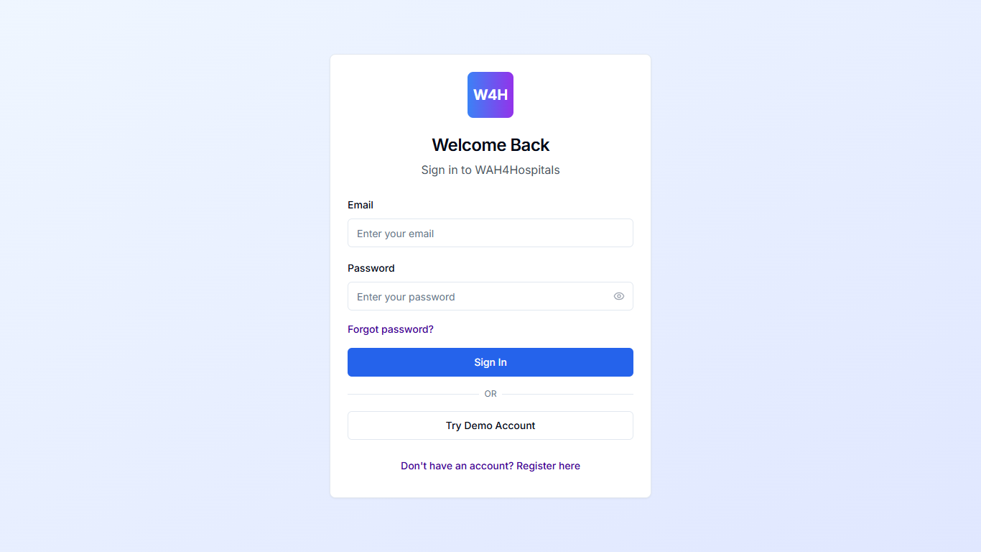
Figure 1. Login Page
Description: This figure shows the login screen where users enter their credentials to access the system.

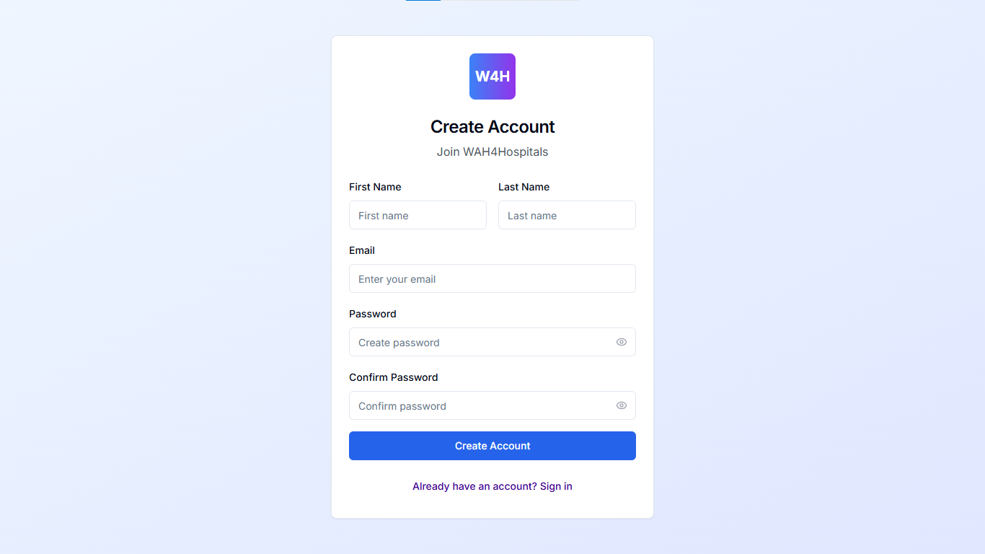
Figure 2. Sign Up Page
Description: This figure illustrates the registration interface for new users, allowing them to create accounts with role-specific permissions.

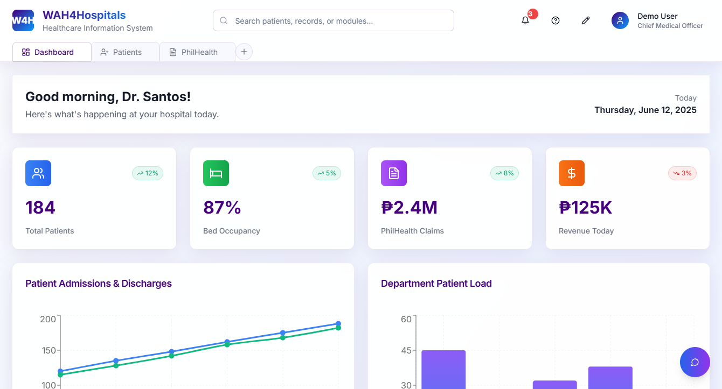
Figure 3. System Dashboard Tab
Description: This figure showcases the main dashboard of the system, providing an overview of key metrics and quick access to modules like patient management, billing, and reports.
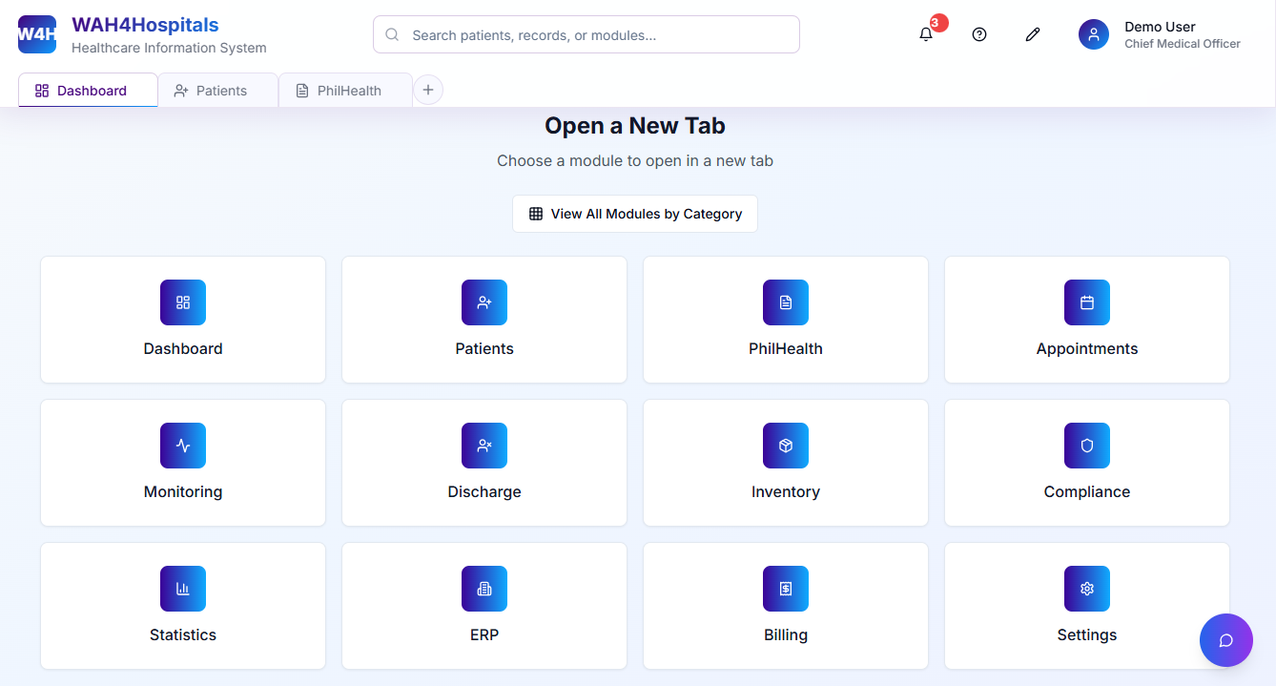
Figure 4. Modules Selection Tab
Description: Illustrates the interface for navigating between system modules.
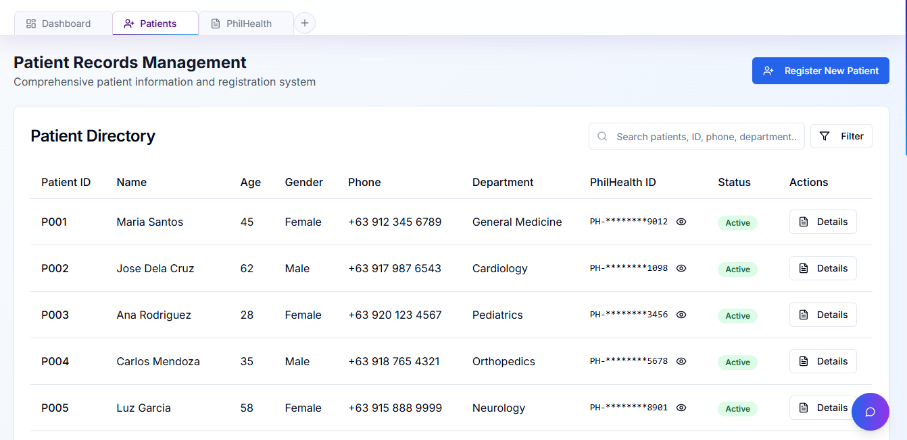
Figure 5. Patients Management Tab
Description: Focuses on managing patient records and consultations.

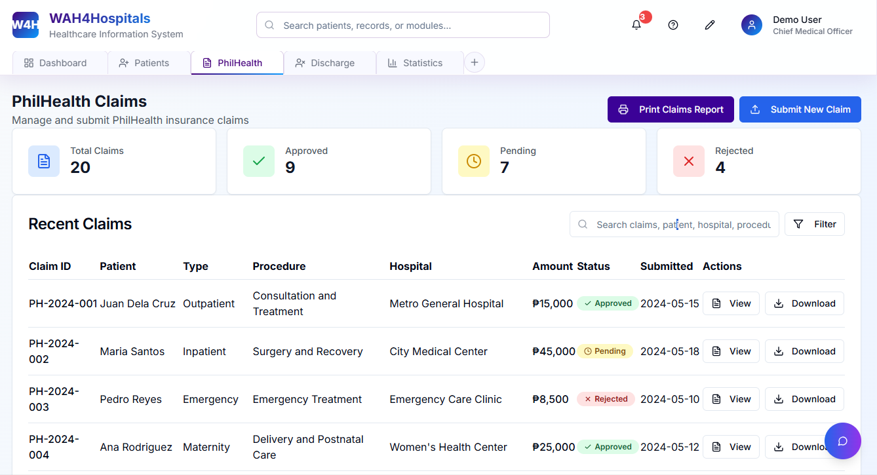
Figure 6. Philhealth E-Claims Tab
Description: Demonstrates the module for preparing and submitting PhilHealth claims.
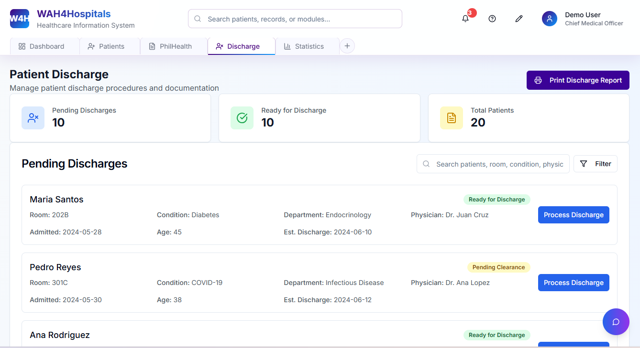
Figure 7. Patient Discharge Tab
Description: Covers the process for handling patient discharge and final documentation.
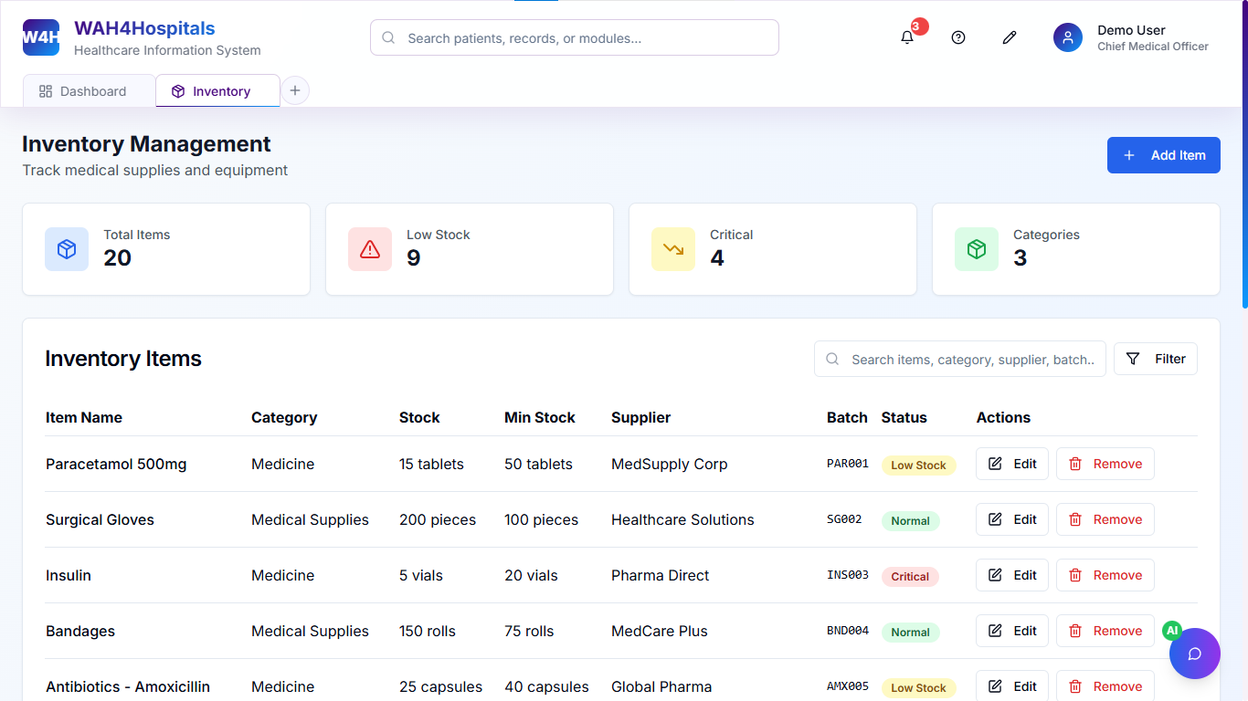
Figure 8. Inventory Management Tab
Description: Tracks medical supplies and equipment within the hospital.
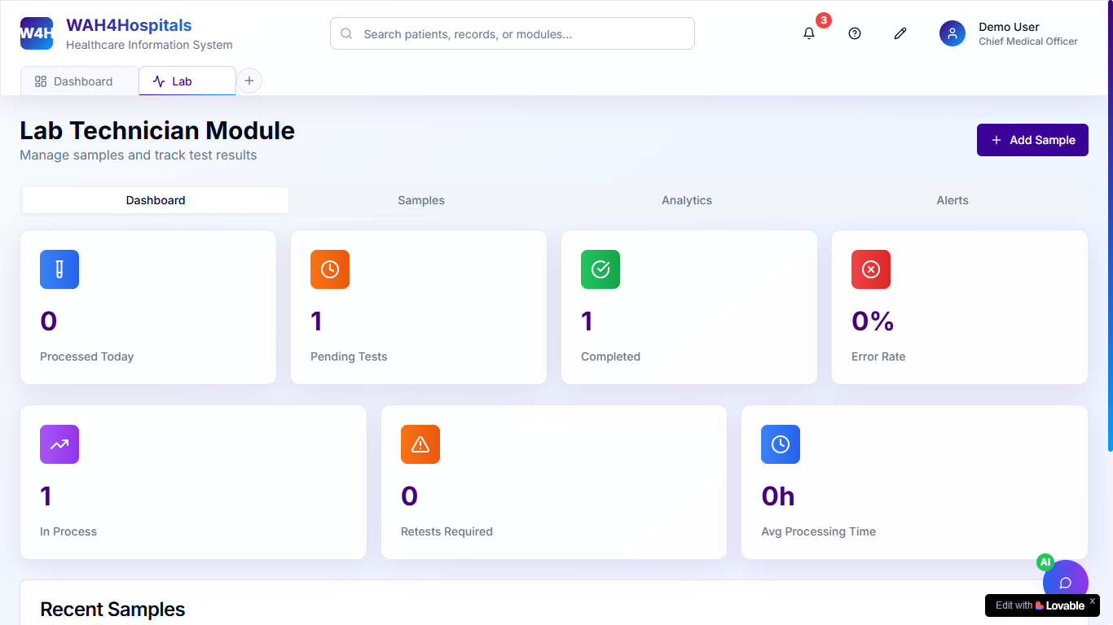
Figure 9. Lab Technician Tab
Description: Manages lab test results and related data.
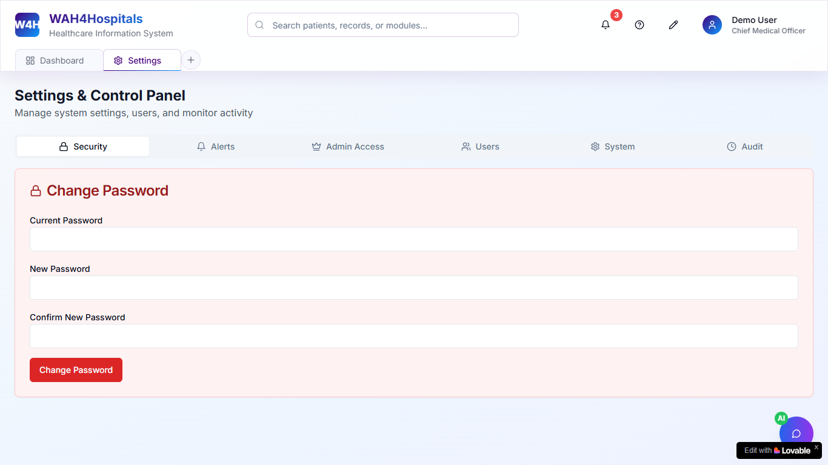
Figure 10. Control Panel Tab
Description: Provides admin tools for managing system settings and user roles.
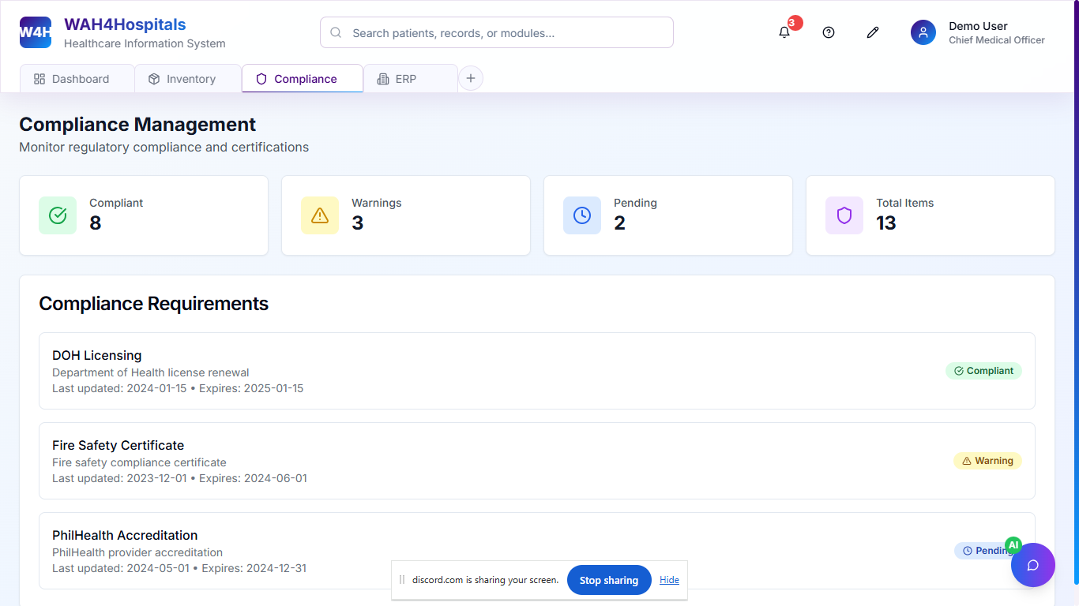
Figure 11. Compliance Management
Description: Ensures adherence to healthcare regulations and standards.

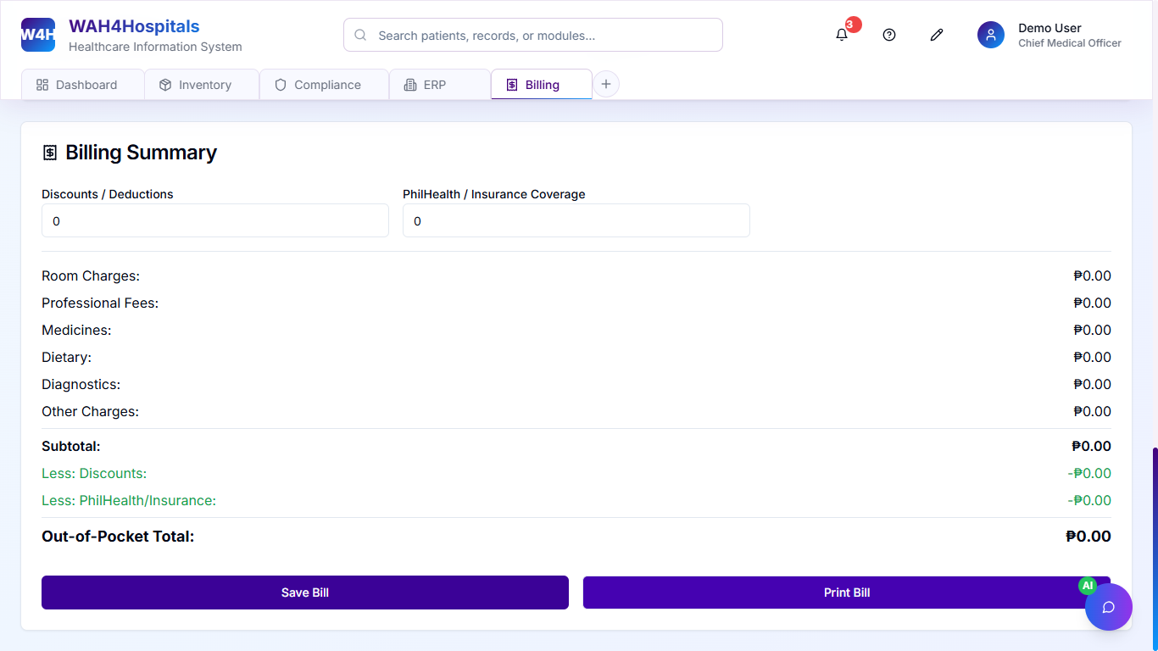
Figure 12. Billing Tab
Description: Handles billing, charges, and invoice generation.
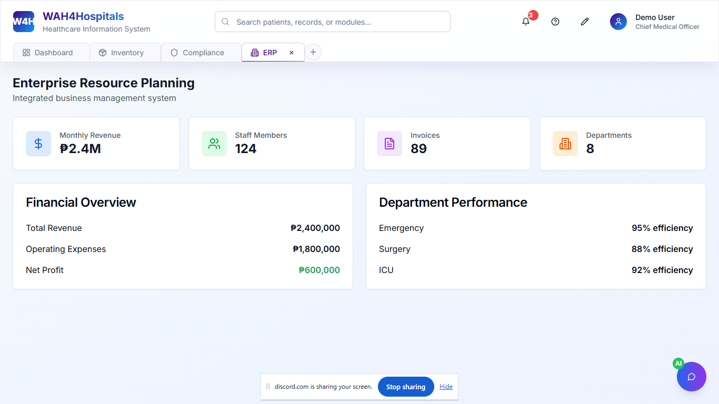
Figure 13. Enterprise Resources Planning Tab
Description: Integrates hospital operations like payroll and finance.
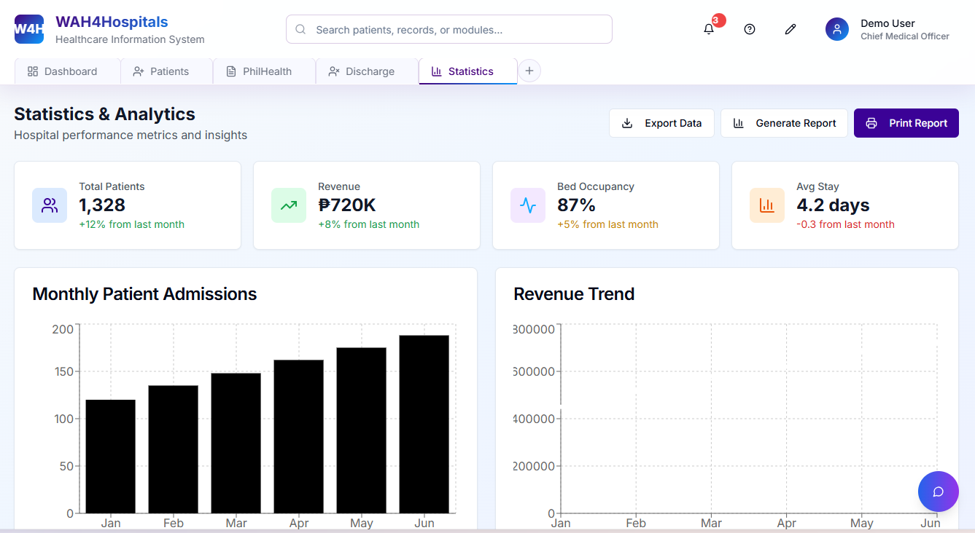
Figure 14. Statistics & Analytics Tab
Description: Offers insights into hospital performance through reports and visualizations.
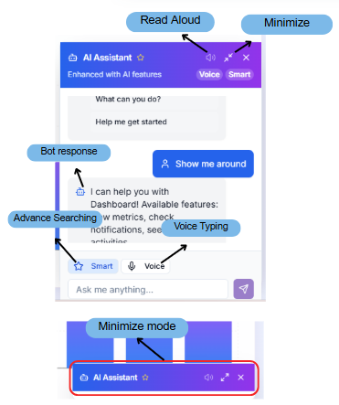
Figure 15. A.I. Chat Bot
Description: Assists users with queries and support through an AI-powered chatbot.

Project Lean Canvas
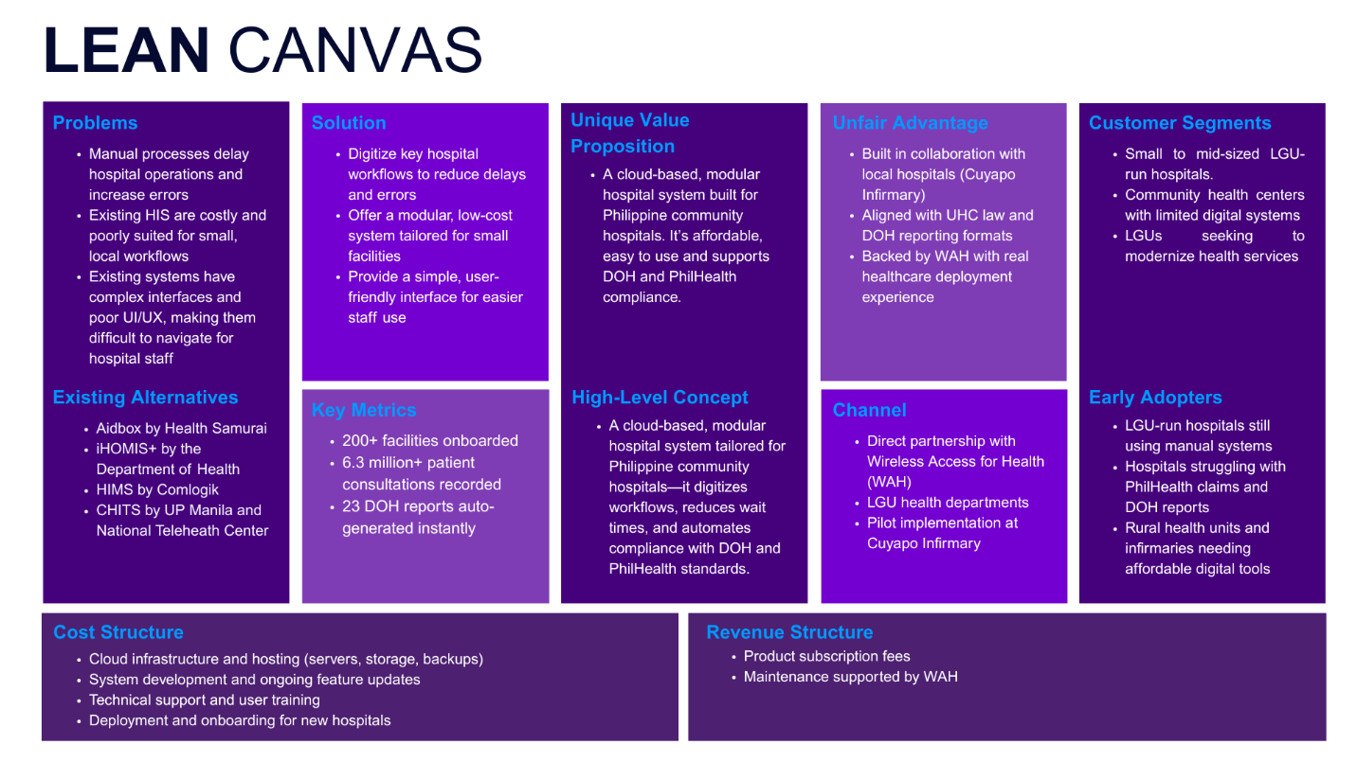
Figure 16. Lean Canvas

User Classes and Characteristics

The WAH4Hospital system is designed to serve a diverse range of users within a hospital setting, each with unique roles, responsibilities, and technical proficiency. To ensure system usability and efficiency, it is crucial to identify the various user classes and understand their specific needs and interactions with the system.
This section outlines the primary user roles and provides a detailed description of their expected behaviors, goals, and system usage. By clearly defining these user classes, the development team can better tailor the interface, access levels, and feature availability to support a streamlined and intuitive experience for all stakeholders.

User Role | Description
Doctor | Medical professional responsible for diagnosing and treating patients; accesses patient records, history, and test results.
Nurse | Provides patient care, monitors vitals, manages medication schedules, and handles discharge procedures.
Lab Technician | Conducts laboratory tests and uploads results into the system; filters data based on test type or patient.
Billing Officer | Computes charges, generates official receipts, and prepares PhilHealth e-Claims.
Front Desk Clerk | Registers patients, manages check-ins, and ensures smooth onboarding of patient data.
Medical Records Officer | Manages digital patient records and ensures data is organized and filterable.
Hospital Administrator | Oversees system operations, generates performance and compliance reports, and monitors access logs.
Patient (External) | Indirect user; receives faster services and documents like receipts, discharge summaries, etc.
Table 4. User Roles and Description

Product Backlog
As a... | I want to be able to... | So that... | Priority
Nurse | view and manage daily tasks and patient rounds from the dashboard | I can stay organized throughout my shift | Must
Nurse | look up a patient's medication schedule | I can ensure timely administration | Must
Discharge Nurse | print discharge summaries in a structured format | patients can understand them easily | Must
Front Desk Clerk | use a clean and organized interface to check in patients | I can improve service time | Must
Medical Records Officer | filter patients by department, admission date, or diagnosis | I can generate specific lists efficiently | Must
Lab Technician | filter test results by patient name or test type | I can avoid data overload | Must
Lab Technician | track error logs and user reports | I can diagnose and fix problems quickly | Must
Doctor | search for a patient’s medical history using keywords or patient ID | I can access relevant records without delay | Must
Senior Hospital Staff | navigate the system easily without advanced computer skills | I can accomplish tasks independently | Should
Billing Officer | print patient invoices in a formal, readable format | I can submit them to patients and insurance providers | Must
Hospital Administrator | generate reports on admissions, bed occupancy, and performance | I can support management decisions | Must
Compliance Officer | view logs of who accessed, edited, or deleted patient records | I can ensure accountability and investigate issues when needed | Must
Admin | customize user access levels | each department sees only relevant information | Must
Hospital Administrator | generate access history reports | I can check for unauthorized actions or data breaches | Should
Table 5. Product Backlog

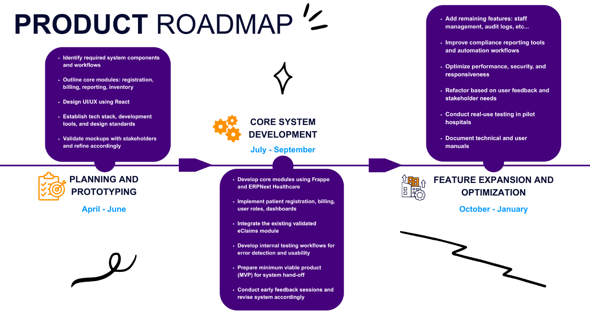
Product Roadmap

Figure 17. Project Roadmap for WAH4H

Release Plan
You can access the release plan from this link: Pseudoers Release Plan.docx

Use Case Diagram
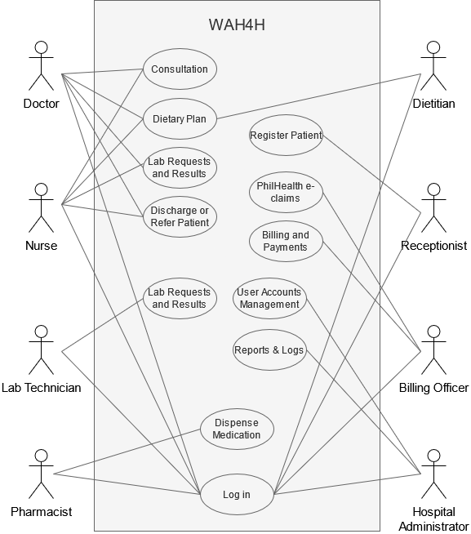
Figure 18. Use Case Diagram

Figure [number] presents the Use Case diagram for the proposed hospital information system, WAH4H. The diagram illustrates the key system actors—including doctors, nurses, pharmacists, receptionists, billing officers, and hospital administrators—and their interactions with core system functionalities such as patient registration, consultations, lab requests, billing, dietary planning, and PhilHealth e-claims processing. It highlights the system’s modular workflow designed to support various healthcare roles in local hospital settings.

Use Case Full Description
You can access the full description of the use case from this link: WAH4Hospital Version 1.0 Fully Dresed Used Case Diagram.docx

Conclusion
The WAH4Hospital (WAH4H) project was developed to support small and LGU-managed hospitals in their transition from manual to digital processes. It does not seek to solve all institutional challenges but instead provides a practical tool to assist hospital staff in handling key administrative tasks more efficiently. By focusing on patient registration, billing, PhilHealth e-claims, and reporting, the system aims to ease repetitive work, reduce errors, and support compliance with national healthcare standards.
Through stakeholder consultations, field visits, and iterative planning, the team was able to identify common workflow issues and design system features that are both usable and sustainable for resource-constrained environments. The project achieved its main goals, including the design of core modules, stakeholder alignment, feasibility assessments, and the creation of a working prototype.
While full deployment and testing remain for future phases, WAH4H demonstrates that well-designed, user-centered digital tools can meaningfully support public healthcare workers. It lays the groundwork for broader implementation and continued improvement toward more accessible and efficient hospital operations.

References

[1] | R. B. H. ICT, "The Hardest Mile is the First: Prioritizing What Really Matters in Healthcare IT," 2021. [Online]. Available: https://medium.com/rock-bottom-health-ict/the-hardest-mile-is-the-first-prioritizing-what-really-matters-in-healthcare-it-cbca73a92ad5. [Accessed 2025].
[2] | W. H. Organization, "Digital Health in the Philippines: Challenges and Opportunities," WHO Western Pacific Region, Manila, 2020.
[3] | M. L. C. G. Dizon and e. al., "Normalization of Electronic Medical Records in Routine Healthcare Work Amidst Ongoing Digitalization of the Philippine Health System," Social Science & Medicine, vol. 307, 2022.
[4] | R. International, "Philippines Wireless Access for Health," 2016. [Online]. Available: https://www.rti.org/node/1663. [Accessed 2025].
[5] | P. Canlas, "The Perceived Benefits on the Use of an Open-Source e-Health Platform in Tarlac Province, Philippines," 2013.
[6] | R. o. t. Philippines, "Universal Health Care Act (Republic Act No. 11223)," Official Gazette, Manila, 2019.
[7] | D. A. o. t. Philippines, "Citizen-Centered Services: Productivity Gains, Outcomes, and Impact," Compendium of Public Sector Innovations, Manila, 2020.
[8] | P. J. Acacio-Claro and e. al., "Understanding Adoption of Electronic Medical Records (EMRs) During a Health Emergency: An Analysis of EMR Usage Logs from Rural Health Facilities in the Philippines," Acta Medica Philippina, vol. 58, no. 22, 2024.
[9] | A. M. Ongkeko Jr. and e. al., "Promises and Realities of Electronic Health Information Systems in the Philippines," Acta Medica Philippina, vol. 58, no. 22, 2024.
[10] | SeeYouDoc, "SeeYouDoc – Access Healthcare in the Philippines," 2024. [Online]. Available: https://seeyoudoc.com.
[11] | Aidbox, "FHIR Server for Healthcare Apps and Analytics," 2025. [Online]. Available: https://aidbox.app.
[12] | GNU Health, "Freedom and Equity in Healthcare," 2025. [Online]. Available: https://www.gnuhealth.org.

Appendices

Pseudoers Members:
JN – Jhon Lloyd Nicolas
EQ – Elijah Josh Quibin
MC – Mariyah Vanna Monique Chavez
JJ – John Kenneth Jajurie

Appendix A: Roles and Responsibilities
WEEK NO. | TASK | DATE ACCOMPLISHED/STARTED | ASSIGNED TO
1 - 2 | Identify and reach out to potential Project Adviser | March 19, 2025 | JN, EQ, MC, and JJ
2 | Develop and set up SharePoint project workspace | March 26, 2025 | JN and EQ
3 | Confirm with Sir Jose Eugenio Quesada as the Project Adviser | April 03, 2025 | JN
4 | Conduct initial consultation with the Project Adviser | April 08, 2025 | JN, EQ, MC, and JJ
4 | Create a FigJam board for collaborative planning | April 10, 2025 | EQ
5 | Participate in project kickoff meeting with WAH Team | April 15, 2025 | JN, EQ, MC, and JJ
6 | Perform initial client research (Manila hospitals) | April 22, 2025 | EQ
7 | Prepare presentation deck for Initial Scoping Meeting | April 27, 2025 | JN and EQ
7 | Attend Initial Scoping Meeting with WAH Team | April 29, 2025 | JN, EQ, MC, and JJ
7 | Conduct post-meeting (Initial Scoping) consultation with Project Adviser | April 29, 2025 | JN, EQ, MC, and JJ
7 | Prepare Midterm Presentation slides | April 29, 2025 | JN, EQ, MC, and JJ
7 | Writing of Project Documentation Paper | May 1, 2025 | JN, EQ, MC, and JJ
7 | Develop the First Use Case Diagram Version | May 1, 2025 | JN
7 | Making the Roadmap Timeline Draft | May 2, 2025 | JN
7 | Design Lean Canvas model for system concept | May 2, 2025 | JJ
7 | Defend midterm project progress and documentation | May 2, 2025 | JN, EQ, MC, and JJ
9 | Attend Online Meetings for WAH4Clinic demo and frontend/backend walk-through | May 13, 2025 | JN, EQ, MC, and JJ
9 | Visit the WAH Headquarters, La Paz Medicare Immersion, La Paz Super Health Center, and Cuyapo Infirmary onsite in Tarlac and Nueva Ecija | May 14, 2025 | JN and EQ
10 | Facilitate sprint retrospective to evaluate team performance | May 18, 2025 | JN, EQ, MC, and JJ
10 | Begin drafting the final project paper | May 18, 2025 | JN, EQ, MC, and JJ
10 | Start developing the Release Plan | May 23, 2025 | JN, EQ, MC, and JJ
12 | Produce promotional video for the project | June 02, 2025 | JN, EQ, MC, and JJ
12 | Present paper and system prototype to Project Adviser for feedback | June 05, 2025 | JN, EQ, MC, and JJ
13 | Defend final project outputs and documentation | June 13, 2025 | JN, EQ, MC, and JJ

Table 6. Pseudoers Assignment of Tasks per Week

Appendix B: Minutes of the Meetings

Minutes of the Meeting # 1

Title: Meeting the Project Adviser
Date: April 08, 2025
Time: 11:30 p.m. – 12:30 p.m.
Platform/Venue: via Teams Meeting
Note-taker: Jhon Lloyd Nicolas (Pseudoers – SS231)
Attendees:
- Sir Jose Eugenio Quesada (PBL Adviser)
- Jhon Lloyd Nicolas (Pseudoers – SS231)
- Elijah Josh Quibin (Pseudoers – SS231)
- Mariyah Vanna Monique Chavez (Pseudoers – SS231)
- John Kenneth Jajurie (Pseudoers – SS231)

Agenda:
- Introduction of Client(WAH)
- Project Overview
- Tech Stack Discussions

Discussion Summary:
In the meeting, the project adviser discussed the client, Wireless Access for Health (WAH), emphasizing their mission to enhance healthcare services through technology. He provided an overview of the project, focusing on developing a Hospital Information System tailored for small healthcare centers, leveraging the Frappe framework specifically designed for healthcare applications. The adviser highlighted Frappe’s strengths in rapid development, modularity, and built-in features suitable for healthcare workflows. He also guided us on how to best utilize the Frappe tech stack to meet the project’s goals of digitizing patient registration, billing, and PhilHealth e-claims while ensuring compliance with DOH regulations.

Minutes of the Meeting # 2

Title: Kick Off Meeting with WAH
Date: April 15, 2025
Time: 5:30 p.m. – 6:40 p.m.
Platform/Venue: via Google Meet
Note-taker: Mariyah Chavez (Pseudoers – SS231)
Attendees:
- WAH Faculty and Staff
- Sir Jose Eugenio Quesada (PBL Adviser)
- Jhon Lloyd Nicolas (Pseudoers – SS231)
- Elijah Josh Quibin (Pseudoers – SS231)
- Mariyah Vanna Monique Chavez (Pseudoers – SS231)
- John Kenneth Jajurie (Pseudoers – SS231)
- Mariel Gravidez (iBugs – MI231)
- Rhundei Zen Ballesteros (iBugs – MI231)
- Nerimiah Jay Ato (iBugs – MI231)
- Rhea-Anne Danao (iBugs – MI231)
- Michael Christian Cecilio (TCG Trio – MI231)
- Julian Rylie Tengco (TCG Trio – MI231)
- Christian Garcia (TCG Trio – MI231)
- Nicky Balderosa (WAH Adviser)
- Ara Bartolome (WAH POC)

Agenda:
- Introduction of WAH Personnel
- Getting to know groups involved in the 3 projects: WAH4H, WAH4P, WAHPC
- Mentioning of Expected Deliverables from the Student Groups

Discussion Summary:
WAH gave a brief background on who they are and the student groups are then introduced to the WAH Team. For the short presentation of WAH, they also mentioned the deliverables they expect to receive from the students based on the schools curriculum, all still depending on what subject the students are currently taking. After the presentation, a short QnA portion was conducted and an online picture taking proper. Before ending the call, the WAH Team also mentioned that expect a new meeting soon for the additional details they would want the student groups to know regarding the specific project assigned to each one of them.

Minutes of the Meeting # 3

Title: WAH4Hospital Initial Scoping
Date: April 29, 2025
Time: 4:30 p.m. – 5:30 p.m.
Platform/Venue: via Google Meet
Note-taker: Jhon Lloyd Nicolas (Pseudoers – SS231)
Attendees:
- WAH Faculty and Staff
- Sir Jose Eugenio Quesada (PBL Adviser)
- Jhon Lloyd Nicolas (Pseudoers – SS231)
- Elijah Josh Quibin (Pseudoers – SS231)
- Mariyah Vanna Monique Chavez (Pseudoers – SS231)
- John Kenneth Jajurie (Pseudoers – SS231)
- Ara Bartolome (WAH POC)

Agenda:
- Key Stakeholders for WAH4H
- Expectations for the team and project
- Scope and Limitation of the Project
- Processes of the WAH4H

Discussion Summary:
During our discussion with the client regarding WAH4Hospital (WAH4H), we identified the key stakeholders involved, including the healthcare staff at Manila Health Department, the WAH management team, and the patients who will benefit from the system’s improved services. We outlined the expectations for both the team and the project, emphasizing our commitment to delivering a reliable, user-friendly, and compliant Hospital Information System that streamlines patient registration, billing, and PhilHealth e-claims. We clearly defined the project’s scope and limitations, focusing on core functionalities needed by small healthcare centers while acknowledging constraints such as budget, timeline, and integration capabilities with existing systems. Finally, we reviewed the main processes of WAH4H, detailing how the system will support clinical and administrative workflows to enhance operational efficiency and patient care.

Minutes of the Meeting # 4

Title: Follow Up Meeting with the Adviser after the WAH Initial Scoping
Date: April 29, 2025
Time: 5:30 p.m. – 6:00 p.m.
Platform/Venue: via Teams Meeting
Note-taker: Jhon Lloyd Nicolas (Pseudoers – SS231)
Attendees:
- Sir Jose Eugenio Quesada (PBL Adviser)
- Jhon Lloyd Nicolas (Pseudoers – SS231)
- Elijah Josh Quibin (Pseudoers – SS231)
- Mariyah Vanna Monique Chavez (Pseudoers – SS231)
- John Kenneth Jajurie (Pseudoers – SS231)

Agenda:
- Feedback from the previous discussion
- Alignment of the team
- Planning for the Project

Discussion Summary:
In the follow-up meeting presided over by our project adviser, we discussed the feedback received from the client during the previous consultation. The adviser acknowledged the clarity of our stakeholder analysis and appreciated our understanding of the client’s priorities, particularly the focus on streamlining core hospital processes through Frappe for Healthcare. He emphasized the importance of ensuring user-centric design and early testing with actual healthcare staff. We also addressed the alignment of our team, confirming roles and responsibilities to ensure efficient collaboration and communication moving forward. Finally, we began detailed planning for the project, outlining key phases such as requirements gathering, system design, development, testing, and deployment, with the adviser recommending that we adopt an agile approach to allow flexibility in addressing real-time feedback from WAH and its partner facility.

Minutes of the Meeting # 5

Title: Demo of WAH for their WAH4Clinics System
Date: May 13, 2025
Time: 9:30 a.m. – 11:30 a.m.
Platform/Venue: via Google Meet
Note-taker: Mariyah Chavez (Pseudoers – SS231)
Attendees:
- WAH Faculty and Staff
- Sir Jose Eugenio Quesada (PBL Adviser)
- Jhon Lloyd Nicolas (Pseudoers – SS231)
- Elijah Josh Quibin (Pseudoers – SS231)
- Mariyah Vanna Monique Chavez (Pseudoers – SS231)
- John Kenneth Jajurie (Pseudoers – SS231)
- Mariel Gravidez (iBugs – MI231)
- Rhundei Zen Ballesteros (iBugs – MI231)
- Nerimiah Jay Ato (iBugs – MI231)
- Rhea-Anne Danao (iBugs – MI231)
- Michael Christian Cecilio (TCG Trio – MI231)
- Julian Rylie Tengco (TCG Trio – MI231)
- Christian Garcia (TCG Trio – MI231)

Agenda:
- Tell what is WAH4Clinics
- Demo how the WAH4Clinic System Works
- Assess if the students understood how WAH4Clinic Works by letting them use it and take Google Forms
- Introduce the WAHcademy: Tutorial Compilation of how to use the WAH4Clinic System

Discussion Summary:
The meeting introduced WAH4Clinics, highlighting its role in digitizing healthcare workflows in LGU-managed facilities. A live demo showcased key features such as patient registration, household linking, and navigation of the home page layout. Participants created their own training accounts and explored the system hands-on, including how to manage Individual Treatment Records (ITRs) and input consultation details. Role-based access was emphasized, with feature availability depending on user designation. The session concluded with the introduction of WAHcademy, a tutorial resource, and a Google Form assessment to evaluate participants’ understanding.

Minutes of the Meeting # 6

Title: Discussion of the Front End and Back End of the WAH4Clinics System
Date: May 13, 2025
Time: 1:30 p.m. – 3:30 p.m.
Platform/Venue: via Google Meet
Note-taker: Mariyah Chavez (Pseudoers – SS231)
Attendees:
- WAH Faculty and Staff
- Sir Jose Eugenio Quesada (PBL Adviser)
- Jhon Lloyd Nicolas (Pseudoers – SS231)
- Elijah Josh Quibin (Pseudoers – SS231)
- Mariyah Vanna Monique Chavez (Pseudoers – SS231)
- John Kenneth Jajurie (Pseudoers – SS231)
- Mariel Gravidez (iBugs – MI231)
- Rhundei Zen Ballesteros (iBugs – MI231)
- Nerimiah Jay Ato (iBugs – MI231)
- Rhea-Anne Danao (iBugs – MI231)
- Michael Christian Cecilio (TCG Trio – MI231)
- Julian Rylie Tengco (TCG Trio – MI231)
- Christian Garcia (TCG Trio – MI231)

- Show how the Frontend and Backend is done
- Discuss how the modules create for both Frontend and Backend communicates
- Show how the Frontend and Backend is done
- Discuss how the modules create for both Frontend and Backend communicates

Discussion Summary:
The meeting provided a technical walkthrough of both the frontend and backend development of the WAH system. John Vincent Antonio demonstrated the “Adolescent” module built using Angular, highlighting component structure and key commands like ng g c, ng g m, and ng serve. He explained how GET and POST methods interact with the API and emphasized using the Console and Network tab for debugging. He also noted best practices such as removing console logs for security and starting designs with wireframes in Figma.
Jerimie Ian handled the backend demonstration, showcasing Laravel (PHP) with MySQL and Postman. He outlined essential components like Model, Migration, Resource, and Controller, and discussed naming conventions, database setup using ERDs, and generating data with Seeders and Factories. He also emphasized the importance of declaring foreign keys and showed how API responses are structured using Resources. It was confirmed that the team will be given access to the WAH code repository.
The session successfully met the agenda objectives by demonstrating how frontend and backend modules are developed and how they communicate through API integration.

Minutes of the Meeting # 7

Title: Tarlac Onsite
Date: May 14, 2025
Time: 7:00 a.m. – 7:28 a.m.
Platform/Venue: Wireless Access for Health (WAH) Headquarters
Note-taker: Elijah Josh Quibin
Attendees:
- Sir Jose Eugenio Quesada (PBL Adviser)
- Jhon Lloyd Nicolas (Pseudoers – SS231)
- Elijah Josh Quibin (Pseudoers – SS231)
- Mariel Gravidez (iBugs – MI231)
- Rhundei Zen Ballesteros (iBugs – MI231)
- Nerimiah Jay Ato (iBugs – MI231)
- Rhea-Anne Danao (iBugs – MI231)
- Julian Rylie Tengco (TCG Trio – MI231)
- Christian Garcia (TCG Trio – MI231)
- Nicky Balderosa (WAH Adviser)
- Ara Bartolome (WAH POC)

Agenda:
- First face-to-face meeting with the client
- Introduction of WAH staffs
- Introduction of group representatives
- Mission and Vision of WAH

Discussion Summary:
WAH welcomed our group to their headquarters, first we were asked about what our comments for their existing website were. We gave them our thoughts on the positives and negatives along with possible solutions. We then were briefed on how hospitals follow DoH and LGU standards and the many partners WAH has. Lastly, it was discussed that on the next venue that we fully utilize the chance to ask questions and know the current situation for LGU hospitals.

Minutes of the Meeting # 8

Title: Interview at La Paz Medicare Immersion
Date: May 14, 2025
Time: 8:30 a.m. - 11:30 a.m.
Platform/Venue: La Paz Medicare Immersion
Note-taker: Elijah Josh Quibin (Pseudoers – SS231)
Attendees:
- Sir Jose Eugenio Quesada (PBL Adviser)
- Jhon Lloyd Nicolas (Pseudoers – SS231)
- Elijah Josh Quibin (Pseudoers – SS231)
- Mariel Gravidez (iBugs – MI231)
- Rhundei Zen Ballesteros (iBugs – MI231)
- Nerimiah Jay Ato (iBugs – MI231)
- Rhea-Anne Danao (iBugs – MI231)
- Julian Rylie Tengco (TCG Trio – MI231)
- Christian Garcia (TCG Trio – MI231)
- Nicky Balderosa (WAH Adviser)
- Ara Bartolome (WAH POC)
- Ms “Lou” (La Paz Nurse)

Agenda:
- Group Immersion on live hospital workflows and processes
- Demonstration of their current HIS
- QnA portion for additional clarification

Discussion Summary:
A nurse representative, Ms. Marilou demonstrated to us their current HIS, it was said that the learning curve to learn and navigate through the system is high. Given that the system was very complex and had many components leading to information overload, many nurses sticked with the traditional way of using paper for records. Many issues also were tackled such as printing formatting of their software, data duplication, and filtering issues where it was hard to navigate through patient information.

Minutes of the Meeting # 9

Title: Interview at La Paz Super Health Center
Date: May 14, 2025
Time: 1:00 p.m. – 2:00 p.m.
Platform/Venue: La Paz Super Health Center
Note-taker: Elijah Josh Quibin (Pseudoers – SS231)
Attendees:
- Sir Jose Eugenio Quesada (PBL Adviser)
- Jhon Lloyd Nicolas (Pseudoers – SS231)
- Elijah Josh Quibin (Pseudoers – SS231)
- Mariel Gravidez (iBugs – MI231)
- Rhundei Zen Ballesteros (iBugs – MI231)
- Nerimiah Jay Ato (iBugs – MI231)
- Rhea-Anne Danao (iBugs – MI231)
- Julian Rylie Tengco (TCG Trio – MI231)
- Christian Garcia (TCG Trio – MI231)
- Nicky Balderosa (WAH Adviser)
- Ara Bartolome (WAH POC)
- La Paz Super Health Center Volunteers

Agenda:
- Group Immersion on live hospital workflows and processes
- Demonstration of their current HIS
- QnA portion for additional clarification

Discussion Summary:
Next location was La Paz Super Health Center, this time this health center implemented the WAH system. The processes were clean and systematic. There were no questions this time since WAH system already answers the common problems of the previous La Paz Medicare Immersion.

Minutes of the Meeting # 10

Title: Cuyapo Infirmary FTF Client Meeting
Date: May 14, 2025
Time: 3:00 p.m. – 4:00 p.m.
Platform/Venue: Cuyapo Infirmary
Note-taker: Elijah Josh Quibin (Pseudoers – SS231)
Attendees:
- Sir Jose Eugenio Quesada (PBL Adviser)
- Jhon Lloyd Nicolas (Pseudoers – SS231)
- Elijah Josh Quibin (Pseudoers – SS231)
- Mariel Gravidez (iBugs – MI231)
- Rhundei Zen Ballesteros (iBugs – MI231)
- Nerimiah Jay Ato (iBugs – MI231)
- Rhea-Anne Danao (iBugs – MI231)
- Julian Rylie Tengco (TCG Trio – MI231)
- Christian Garcia (TCG Trio – MI231)
- Nicky Balderosa (WAH Adviser)
- Ara Bartolome (WAH POC)
- Benditha Babac (Cuyapo Infirmary POC)
Agenda:
- Group Immersion on live hospital workflows and processes
- Client elaborates needs and wants for the upcoming system
- QnA portion for additional clarification

Discussion Summary:
Cuyapo Infirmary, elaborated on the emergency and in-patient workflows. They made suggestions on what they want to see on the upcoming HIS system WAH4Hospitals. We had a small discussion on their previous experience using HIS. And lastly, shared their contact information for communcation.

Minutes of the Meeting # 11

Title: Paper Consultation and Defense Preparation with Project Adviser
Date: June 05, 2025
Time: 5:40 p.m. – 7:30 p.m.
Platform/Venue: APC 5th Floor Room 508A
Note-taker: Elijah Josh Quibin (Pseudoers – SS231)
Attendees:
- Sir Jose Eugenio Quesada (PBL Adviser)
- Jhon Lloyd Nicolas (Pseudoers – SS231)
- Elijah Josh Quibin (Pseudoers – SS231)
- Mariyah Vanna Monique Chavez (Pseudoers – SS231)
- John Kenneth Jajurie (Pseudoers – SS231)

Agenda:
- Review the content of the progress of Finals Paper of the group
- Consult the Project Adviser with other group deliverables
- Review the current prototype of the group regarding the system

Discussion Summary:
The meeting focused on reviewing the group’s final paper and system prototype in preparation for the upcoming defense. Key points discussed included refining the project context, clarifying the system's current development status, and aligning the write-up with stakeholder expectations. The adviser provided feedback on improving the tone of the paper, ensuring legal and policy references—such as those related to Universal Health Care—are properly integrated. The importance of clearly presenting the current manual processes and positioning the system as a developing solution was emphasized. The team was also advised to revise certain sections to better define the scope, beneficiaries, and implementation details. Additional input was given on research alignment and presentation strategies to strengthen the overall output.

Appendix C: Methodology

This project was developed using the Agile methodology, following Scrum practices to manage tasks and track progress. Each sprint assigned a different team member as Scrum Master, giving everyone a chance to lead while contributing to the technical work. As sprints progressed, key modules—such as patient records, user management, and billing—were gradually completed. Documentation for the research paper was also updated alongside development. At the end of each sprint, the team held sprint retrospectives to review what worked, what didn’t, and what could be improved. This helped the team adjust and improve how we worked together. Using this method also kept us aligned with the digital processes currently used by our project stakeholder, WAH.

Appendix D: Project Sharepoint Link

Pseudoers Team Sharepoint Link: Home Sharepoint

Appendix E: Requirements Traceability Matrix

Business Rqt No | Use Case ID | Test Case ID
BR-01 | UC-01 | TC-01
BR-02 | UC-02 | TC-02
BR-03 | UC-03 | TC-03
BR-04 | UC-04 | TC-04
BR-05 | UC-05 | TC-05
BR-06 | UC-06 | TC-06
BR-07 | UC-07 | TC-07
BR-08 | UC-08 | TC-08
BR-09 | UC-09 | TC-09
BR-10 | UC-10 | TC-10

Appendix F: RACI Matrix

Legend:
R | Responsible
A | Accountable
C | Consulted
I | Informed

Tasks / Deliverables | Project Adviser | Project Manager | Frontend Dev | Backend Dev | Testers | WAH Rep | Cuyapo Rep
Requirements Gathering | C | R | I | I | I | A | A
System  Design | C | A | R | C | I | I | I
Frontend Development | C | A | R | C | I | I | I
Documentation | C | R | R | R | I | I | I
Testing | C | A | C | C | R | I | I

